CST 229 – Assignment 2 part 1 – Finite Automata
Wilsonville, Fall 2020

- a) Draw the following NFA as a state diagram:

State | a | b | λ | Accept?
1 | 3 | 1 | 2
2 | 1 | 2
3 | 4 | 1 |  | Yes
4 | 2 | 3 | 1

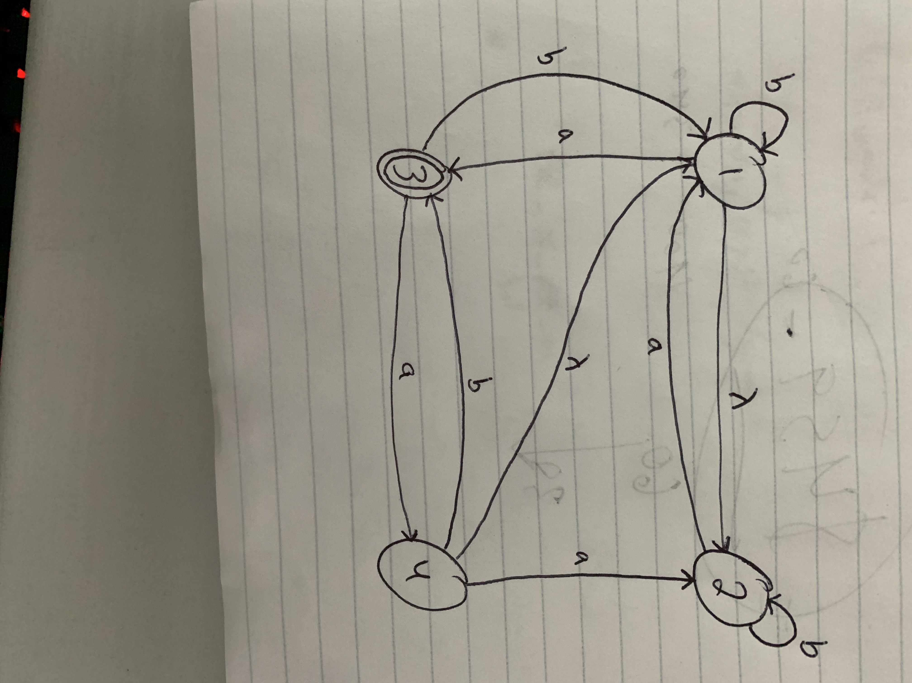

b) Construct the equivalent DFA and show all work.

DFA State | a | b | Accept?
P{1,2} | Q | P
Q{1,2,3} | R | P
R{1,2,3,4} | R

DFA State | a | b | Accept?
P{1,2} | Q | P
Q{1,2,3} | R | P
R{1,2,3,4} | R | Q
DFA State | a | b | Accept?
P{1,2} | Q | P
Q{1,2,3} | R | P | Yes
R{1,2,3,4} | R | Q | Yes

- Construct a NFA that recognizes the Regular Expression (ab)⁺|b⁺, and find the equivalent DFA. Show all work.

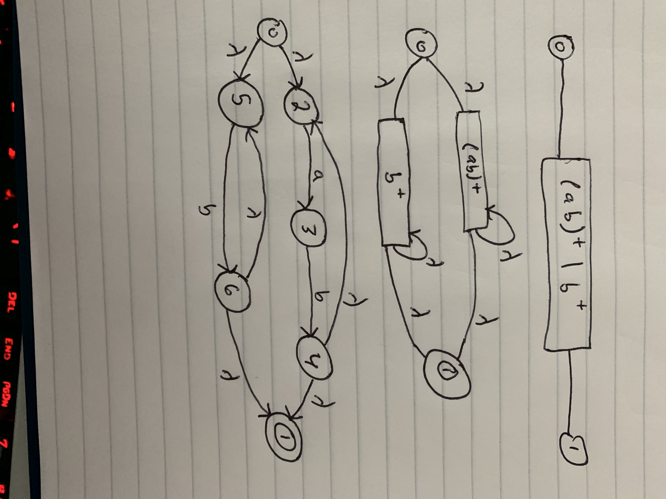

NFA Table:

State | a | b | λ | Accept?
0 |  |  | 2,5
1 |  |  |  | Yes
2 | 3
3 |  | 4
4 |  |  | 1,2
5 |  | 6
6 |  |  | 1,5

DFA Table:

DFA State | a | b | Accept?
P{0,2,5}

DFA State | a | b | Accept?
P{0,2,5} | {2,5,3} | {2,5,6}

DFA State | a | b | Accept?
P{0,2,5} | Q | R
Q{2,5,3}
R{2,5,6}

DFA State | a | b | Accept?
P{0,2,5} | Q | R
Q{2,5,3} | {3} | {4,1,2} | Yes
R{2,5,6} | {3,1} | {6, 1} | Yes

